 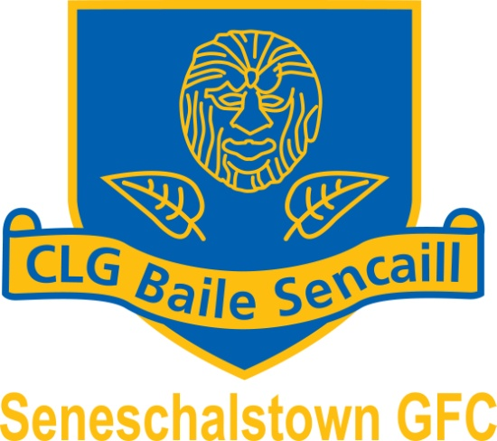 

(<http://www.seneschalstowngaa.com/>)

Chairperson: Secretary : Treasurer :

Noel McLoughlin Declan Kinsella Patrick Clarke

086 – 2753895 087-9392755 041 - 9825437

**Annual General Meeting**

A Chara Club Member

You are cordially invited to attend the Annual General meeting of Seneschalstown GAA Club on **Monday 17*th November 2014 at 8pm in our club hall***.

Please find enclosed a copy of our nomination form. Please turn any Nominations or Motions to me before Monday ***10th November 2014***

Please note that our Mass for deceased members will be held in ***Kentstown Church*** on ***Sunday 16th November @ 11.30am***. As a mark of respect to our deceased members we would appreciate a large attendance at this mass.

Is mise le meas

Declan Kinsella

Secretary

Seneschalstown

  

(<http://www.seneschalstowngaa.com/>)

Chairperson: Secretary : Treasurer :

Noel McLoughlin Declan Kinsella Patrick Clarke

086 – 2753895 087-9392755 041 - 9825437

**Annual General Meeting 17th November 2014**

**Nomination Form**

*To be returned to Club Secretary(Declan Kinsella, Veldonstown, Brownstown, Navan Co Meath) not later than Monday* ***10th November 2014.***

***Note:*** *The consent of the person being nominate* ***must*** *be obtained. Members may be nominated for more than one position*

|  |  |  |
| --- | --- | --- |
| **Position** | **Outgoing** | **Nominations** |
| ***President*** | *Fr.Farrelly, Fr.Coyne, Jimmy McComiskey, Kit Carey, Tommy Collins, Kevin Farrell, Paddy Coyle, Fr.Lynch, Noel Byrne* |  |
| ***Chairperson #*** | *Noel McLoughlin* |  |
| ***Vice – Chairperson*** | *Alan Geraghty* |  |
| ***Secretary#*** | *Declan Kinsella* |  |
| ***Assistant Secretary*** | *Stephen Dillon* |  |
| ***Treasurer #*** | *Pat Clarke* |  |
| ***Assistant Treasurer*** | *John Battersby* |  |
| ***PRO#*** | *Brian Kelly* |  |
| ***Safety Officer*** | *Phonsie Gilsenan* |  |
| ***Coaching/Juvenile Coaching Co-ordinator #*** | *Gerry McDonnell\** |  |
| ***Irish Language Officer #*** | *Liz Sheridan* |  |
| ***Children’s Officer/School Liaison Officer #*** | *Gerry McDonnell* |  |
| ***Insurance Officer/Registrar #*** | *Stephen Dillon* |  |
| ***IT Officer #*** | *Gordon McGuirk \** |  |
| ***Community Liaison Officer/Health and Wellbeing*** | *Dessie Mooney\** |  |
| ***Co. Board Delegate*** | *Declan Kinsella, John Battersby* |  |
| ***Executive Committee*** | *Robert Ruddy, Joe Finnegan, Shane Finnegan, Tony McDonnell, John Battersby, Gordon McGuirk\** |  |

*# Automatic Members of Executive, along with chairman, secretary, treasurer of Juvenile and Ladies committees plus 1 Player Rep and 5 Full members*

*\* Not seeking re-election for that position*

Signature: ________________________ Date: __________________

  

(<http://www.seneschalstowngaa.com/>)

Chairperson: Secretary : Treasurer :

Noel McLoughlin Declan Kinsella Patrick Clarke

086 – 2753895 087-9392755 041 - 9825437

**Annual General Meeting 17th November 2014**

**Motions**

*To be returned to Club Secretary(Declan Kinsella, Veldonstown, Brownstown, Navan Co Meath) not later than* ***Monday 10th November 2014.***

Motion 1: ________________________________________________________________________

________________________________________________________________________

________________________________________________________________________

________________________________________________________________________________________________________________________________________________________________________________________________________________________________________________________________________________________________

Motion 2:

________________________________________________________________________________________________________________________________________________________________________________________________________________________________________________________________________________________________________________________________________________________________________________________________________________________________________________________________________________________________________________________

Signature: ________________________

Date: __________________

…………………………….

Elizabeth Sheridan (Ass. Sec.)

Bellview, Dollardstown, Beauparc

Navan